Resistor
Electronic part hai jo electron ke flow ko rokta hai.
Isme output voltage input voltage se kam hota hai.
Denoting Letter – R, PR
Symbol
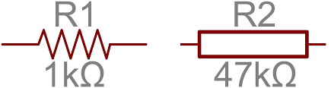
Measure Unit - Ohm
1000 Ohm = 1 Kilo Ohm
1000 Kilo Ohm = 1 Mega Ohm

Real Shape
Two types of resistors
- Solid-type Registor
- SMD (Surface Mount Device)
SMD
There are 4 types of resistors found in the Motherboard.
- Body Printed Resistor

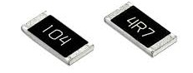

- Non-Printed Resistor - Small size

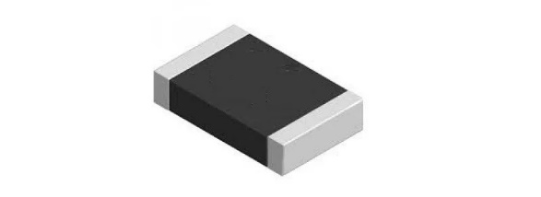

- SMD Pack Resistor / Network Resistor
Denoting Letter – RN /RP

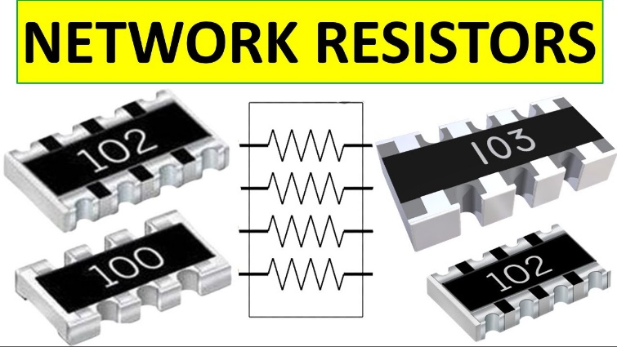

8 legs

- 4 Leg SMD Resistor
Denoting RN

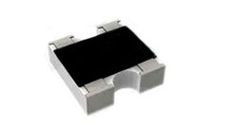

3 Digit Code
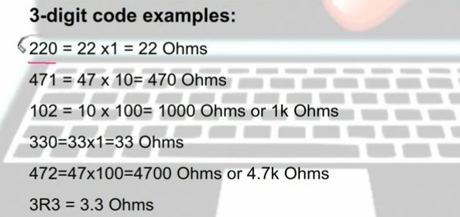

4 Digit Code
